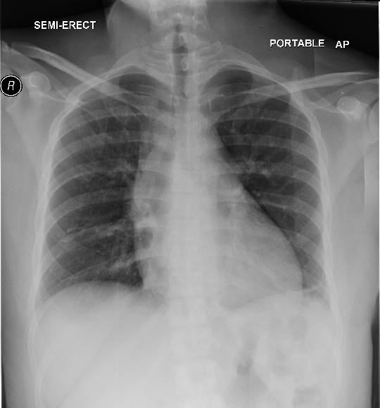

A

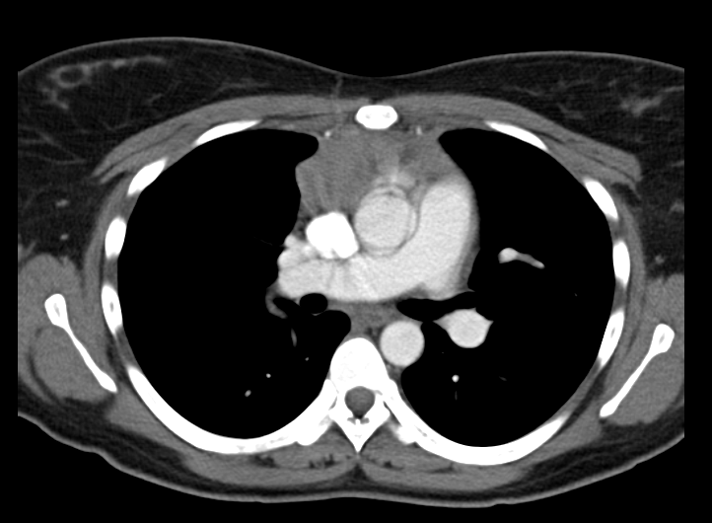

B

This frontal radiograph (image A) from a 30 year old patient demonstrates abnormal lobulated soft tissue density in the mediastinum adjacent to the trachea. The exact location of the mass is difficult to determine given the absence of a lateral radiograph, so a CT was recommended for further evaluation. A contrast enhanced CT image (image B) demonstrates an enhancing soft tissue mass in the anterior mediastinum. Normal residual thymic tissue can sometimes be present in patients of this age, but the size and convex margins of this mass make normal residual thymus unlikely. The differential diagnosis for an anterior mediastinal mass includes the 4 Ts: thymic 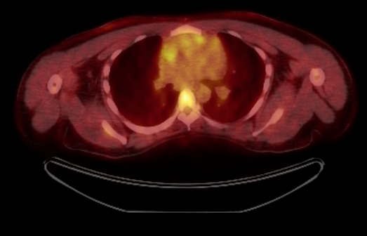lesions (especially thymoma), teratoma (and other germ cell neoplasms), enlarged substernal thyroid, or terrible lymphoma. CT can generally easily diagnose a substernal thyroid if the lesion is contiguous with the thyroid gland higher in the neck. Patient age as well as the presence of fat or calcium can help to narrow the differential diagnosis, although biopsy is usually necessary. A PET-CT was also obtained in this patient (image C) and demonstrates hypermetabolism in the anterior mediastinal mass, although this does not change the differential diagnosis or affect the need for biopsy.

C

Final diagnosis: Anterior mediastinal mass

Author: Nicholas Nacey, MD